The formation is an essential dimension in the life of the Congregation
November 25, 2021

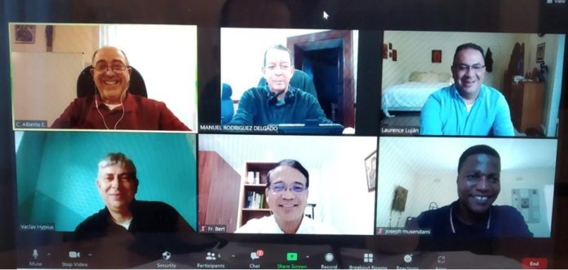Members of the General Secretariat of Formation: C. Alberto Eseverri (president), Manuel Rodríguez Delagado (executive secretary), Larry Lujan (North America), Hypius Václav (Europe), Edilberto Cepe (Asia and Oceania), Joseph Musendami (Africa and Madagascar), Rogerio Gómes (general consultor)

The General Secretariat of Formation celebrated its second-semester meeting during the week of November 22nd, 2021, using the Zoom platform. The Zoom technology has been a blessing as it has offered an alternative to the limited possibilities of in-presence meetings for the last six occasions and a continuation of the works of the Secretariat.
On the first day of meetings Father General, Michael Brehl, was with us and offered various valuable orientations on the perspectives for the future of formation in the Congregation and the role of the General Secretariat of Formation as it contributes to this future.
We listened to reports on formation in the five Conferences.
Fr. General collaborated in these reports, enriching them informing about the different activities in which he participated. Fr. General recognized the enormous progress and work that has been done during the last two sexennium in formation without minimizing the importance of continuing these efforts into the future.
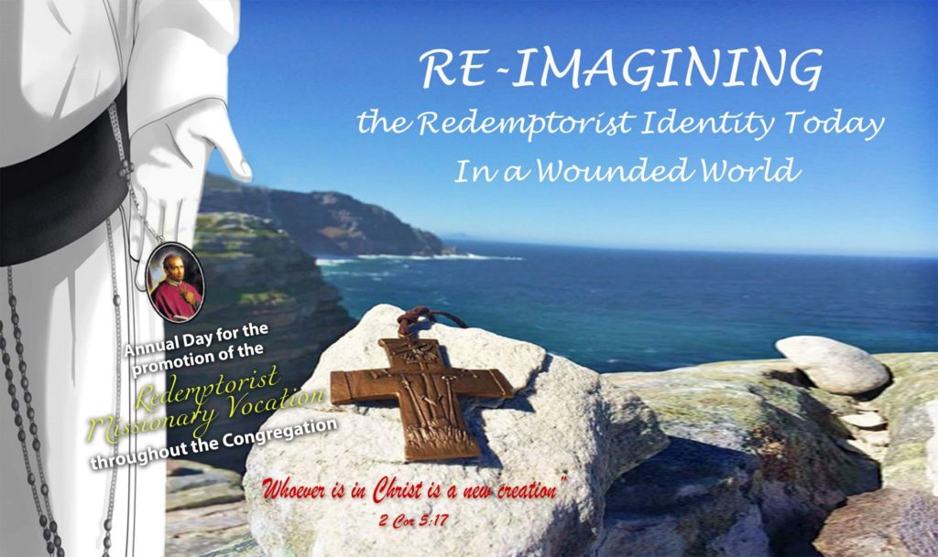

During the week, we focused our attention on the following different themes: the activities of the World Prayer Day for Redemptorist Missionary vocation, the publication of Volumes VI and VII of the series on “Redemptorist Formation”, an evaluation of the General Secretariat of Formation during this sexennium, suggestions of future tasks of this General Secretariat, reflections of the references to formation in the Working Document for the First Phase of the General Chapter, information on the Formation webpage and concretization of suggestions to the next General Government and possible postulates for the General Chapter.
The week was evaluated as very positive, especially as an opportunity to reflect together and share on the formation dimension in the life of the Congregation. Furthermore, we will be attentive to the results and reflections of the First Phase of the General Chapter and determine whether or not we can offer further reflections and contributions on formation as we look forward towards the canonical Phase of the 26º General Chapter and the end of the present sexennium.

Fr. Manuel Rodríguez Delgado, C.Ss.R.

